
Company
Logotype

Cone Beam Computed Tomography- Report



Porur Dental X-rays & CBCT

Patient Name : Mr. Dharaniyan | Date of Report : 10.03.2024
Age/ Gender : 54 years/ Male | Region of Interest : CBCT Maxilla Mandible- Sectional
Referring doctor: Dr. Selva Vigneshwaran | Indication : Implant assessment- 46, Root canal treated tooth assessment-26.
Clinical Notes: Nil
PATIENT INFORMATION

CBCT- Sectional Maxilla Mandible provided
CBCT – IMAGE DETAILS

RADIOGRAPHIC INTERPRETATION

- The tooth 26 is present with hyperdense restorative material involving the pulp canal extending upto the apical third of the roots.
- Presence of hypodense area evident in the periapical region of 26 in relation to the palatal root measuring 4.12 x 4.18 x 4.08 mm in dimension with irregular borders.
- Completely missing crown and root portion in relation to 46.
- The alveolar ridge in relation to 46 is present with normal trabecular pattern.

IMPLANT ASSESSMENT

 | 46 region
Sub-Crestal (in mm) | 4.61
Mid- Crestal (in mm) | 6.26
Distance between alveolar ridge and the inferior alveolar nerve canal (in mm) | 17.32
Distance between alveolar ridge and the inferior border of mandible (in mm) | 28.46

RADIOGRAPHIC IMPRESSION

- Partially edentulous region: 46
- Periapical pathology in root canal treated tooth: 26

Kindly correlate with clinical findings


IMAGES FOR REFERENCE

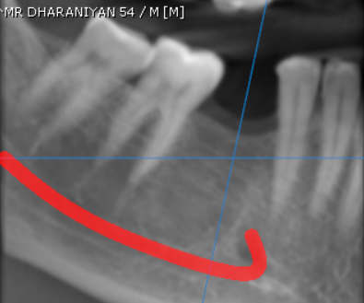
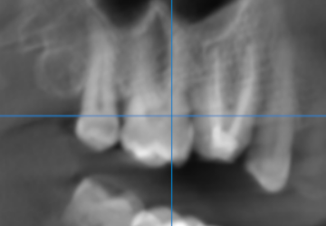

3-DIMENSIONAL VIEW

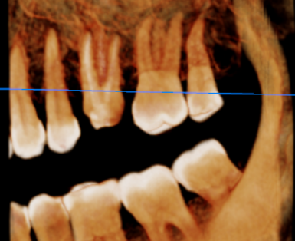
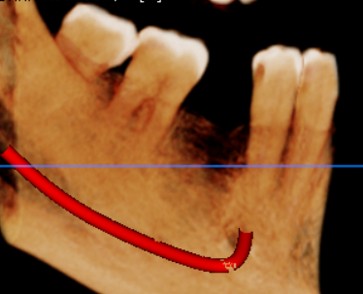

CROSS SECTIONAL VIEW
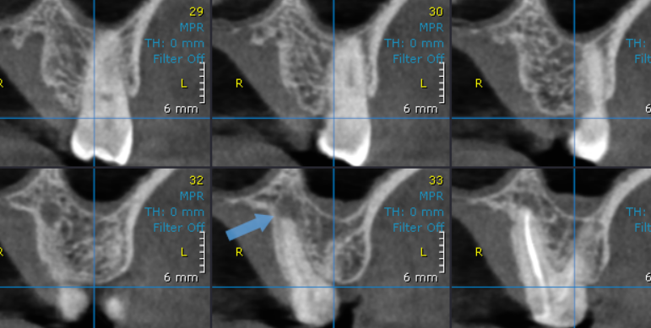
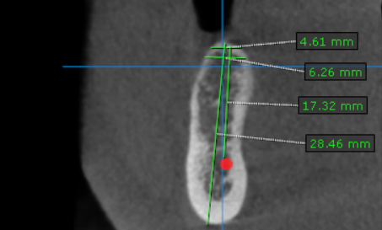
46 region
26 region

**** End of report ****

